Lesson Plan Design Project
Lesson Plan Template

Name: Jason Sexton & Ryan Greene

Date of Demonstration: November 19, 2019

Preparation | Instructional Context and Student Description  (i.e., grade level, subject matter, unit topic, student demographics, school background, and any information you see important) | 8th Grade  Georgia History  Geographic Understandings of Georgia  Public School in North Georgia
Preparation | Standard Addressed | SS8G1 - The student will describe Georgia with regard to physical features and location.  B. Describe the five geographic regions of Georgia; include the Blue Ridge Mountains, Valley and Ridge, Appalachian Plateau, and Coastal Plain  C. Locate and evaluate the importance of key physical features on the development of Georgia: include the Fall Line, Okefenokee Swamp, Appalachian Mountains, Chattahoochee, and Savannah Rivers, and barrier islands.
Preparation | Lesson Objective/Teaching Point | For students to learn the 5 geographic regions of Georgia and their features/characteristics, while collaboratively researching the content and teaching it to one another.
Preparation | Lesson Time | 50 minutes
Preparation | Material | Power Point Slides, Map of Georgia with Regions Handout, Computers
Lesson Details | Procedure | Anticipated Time Frame | Detailed Description | Differentiation for Diverse Learners (Please specify your population of choice.)
Lesson Details | Introduction and Scaffolding | 5 mins | Brief introduction to five geographic regions of Georgia & explain activity to come.
Lesson Details | Engagement with Material  (e.g., content or writer’s craft teaching, teacher modeling, guided practice, independent practice, and/or collaborative practice, etc.) | 20 mins | Collaborative learning opportunity. Students will be broken up into groups of 4-5 (determined by table, with adjustments made by teachers if needed). Each group is assigned a geographic region of Georgia. All students will be given a map of the state of Georgia with regions outlined. First, they will label their own region on the map. They will have 20 minutes to research their region and obtain information that fills in the second handout (graphic organizer). Questions for them to consider include: 1-What type(s) of landscape(s) can be found in the region? 2- Are there any major landforms, if so what are they?  3- What are the major cities in the region (at least 3)  4- What type of climate does your region have? What are the characteristics of this climate?  5-List at least 3 types of plants and 3 types of animals found in your region. We will give students a link to one source (http://bit.do/regionsofga) and encourage them to find any other sources that are useful, allowing the student to determine its credibility. While doing this they will familiarize themselves with their assigned region and prepare to present their findings. | Emergent Bilingual Students – We will translate key terms on the graphic organizer so as to create clarity for what they will be researching. This will be done via word bank.
Lesson Details | Assessment/Evaluation | 20 mins | Each group will then teach the rest of the class about their particular region of Georgia with a brief presentation (4 minutes per group). Students that are not presenting at the time will fill out information for each of the regions as they are being taught by their peers. The presentation will be somewhat informal, a power point or elaborate presentation is not required. It could be as simple as a brief lecture giving the students the required information. The teacher(s) will give support on anything that is unclear during the presentation.
Lesson Details | Closure | 5 mins | Teacher will point out any missed details from groups and wrap up the lesson.

Appendix

Region | Región
Landscape | Paisaje
Major Cities | Ciudades Importantes
Climate | Clima
Plants/Animals | Plantas/Animales

Region | Región
Landscape | Paisaje
Major Cities | Ciudades Importantes
Climate | Clima
Plants/Animals | Plantas/Animales

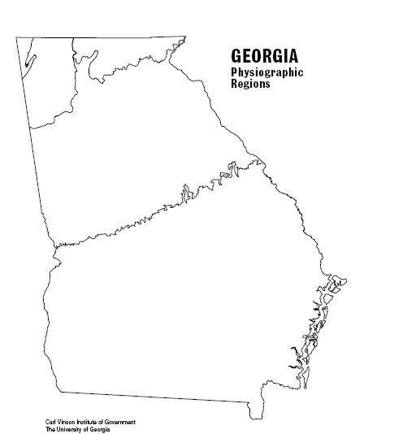
NAME______________________________________________________
Region | Landscape | Major Cities | Climate | Plants/Animals
Appalachian
Plateau

Ridge & Valley
Blue Ridge
Piedmont
Coastal Plain

\